**Learning Objective**

* Master basic CSS debugging skills

**Content**

* CSS is tolerant as HTML. In CSS, if a declaration is invalid (including a grammar error, or the browser does not support it), the browser will completely ignore it and then turn to the next one it finds. However, it will not report such error.
* The same is true for the selector. If the selector is invalid, then it will not select any elements, and the entire rule will do nothing. The browser will only continue executing the next rule, and it will also generate deviation from the design draft.
* All browsers now have built-in page developer tools such as Chrome's DevTools and Firefox's page inspector tool.
* Open Devtools by right-clicking on "Review Elements" in Chrome, or click F12 (Windows) / Cmd+Opt+I (Mac OSX). The opened DevTools are shown below.

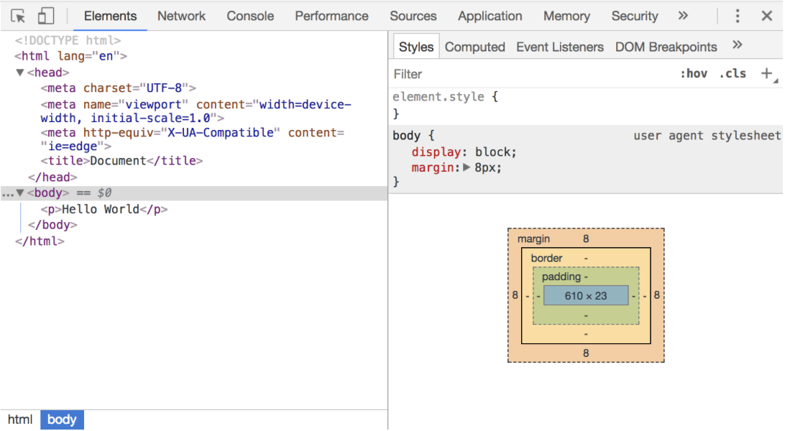

* You can see the following modules:
  + Element tab: it is used to view and edit HTML and CSS elements in the current page.
  + Network tab: it is used to view details of HTTP requests, such as request headers, response headers, and return content.
  + Source tab: it refers to source file for viewing and debugging the scripts loaded by the current page.
  + TimeLine tab: it is used to view information such as script execution time, page element rendering time.
  + Profiles tab: it is used to view information such as CPU execution time and memory usage.
  + Resource tab: it is used to view the resource files requested by the current page, such as HTML and CSS style files. -Audits tab: it is used to optimize front-end pages, speed up page load, etc.
  + Console tab: it is used to display debugging information output in the script, or to run test scripts.
* Next, we will focus on the two modules we use most often:
  + Element module
    - We locate the Element module in DevTools and hover over a DOM node with the mouse, then such element on the left side of the page will be highlighted.

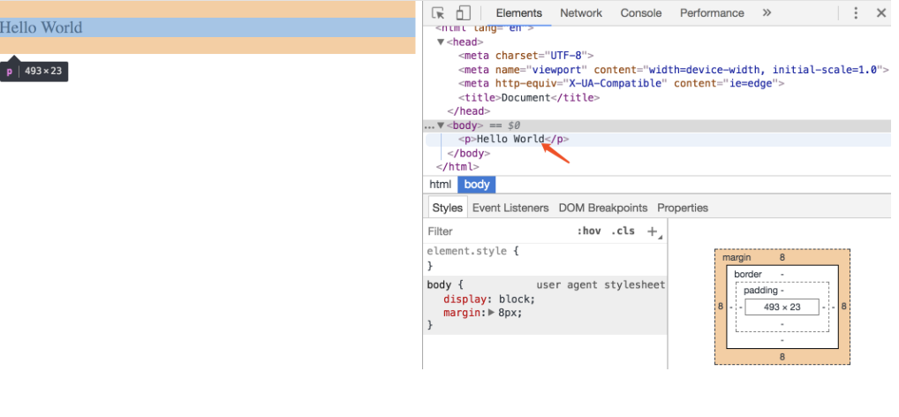

* + - In the Element panel, we can see that there is also a sub-panel called Style. In the Style panel, you can see all the defined CSS attributes of an element, and we can modify the CSS attributes in the Style panel, which will take effect immediately

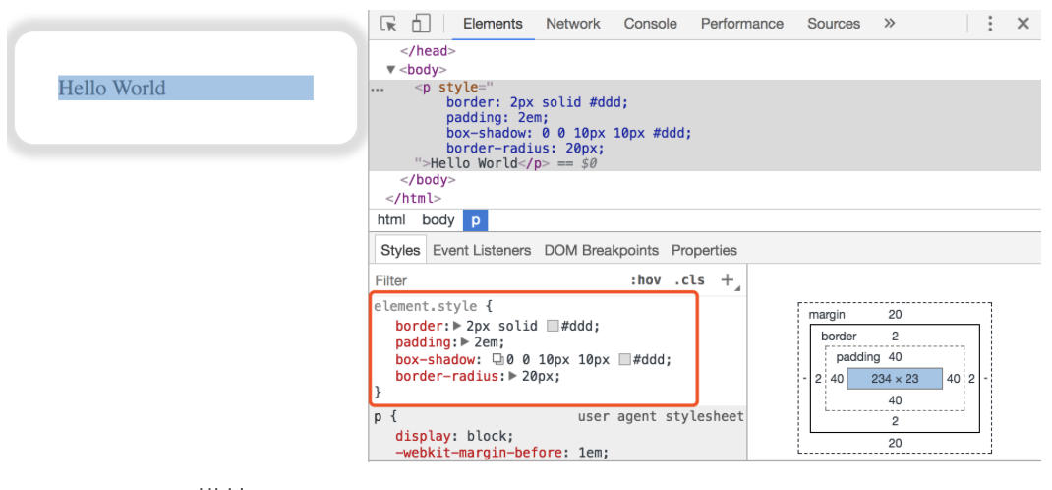

* + Console module
    - We locate the Console module in DevTools. The current module may be used to view and debug the source files of the script loaded by the current page. In other words, we can execute JavaScript scripts in the Console module.

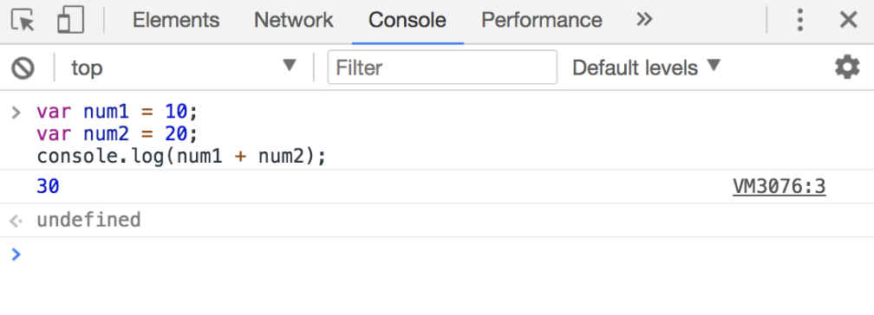

* If there are some errors in our page, we can open the DevTools Console panel and you can see that there is a page error reported in the panel, as follows:

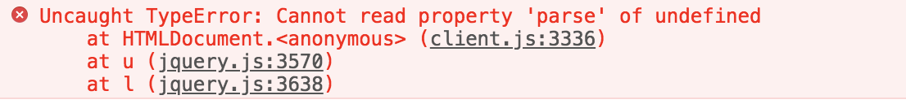

* Of course, the functionality of Chrome DevTools is far more powerful than that in the Element panel and the Console panel. More DevTools tips will be unlocked in subsequent mission cards.
* CSS verification
  + As HTML validator (<http://jigsaw.w3.org/css-validator/>) may verify the same level of HTML specification, there is also a CSS validator (<<http://jigsaw.w3.org/css-> Validator/>) that may verify CSS on a specific URL, or by uploading a local file, or directly using CSS properties for input validation.

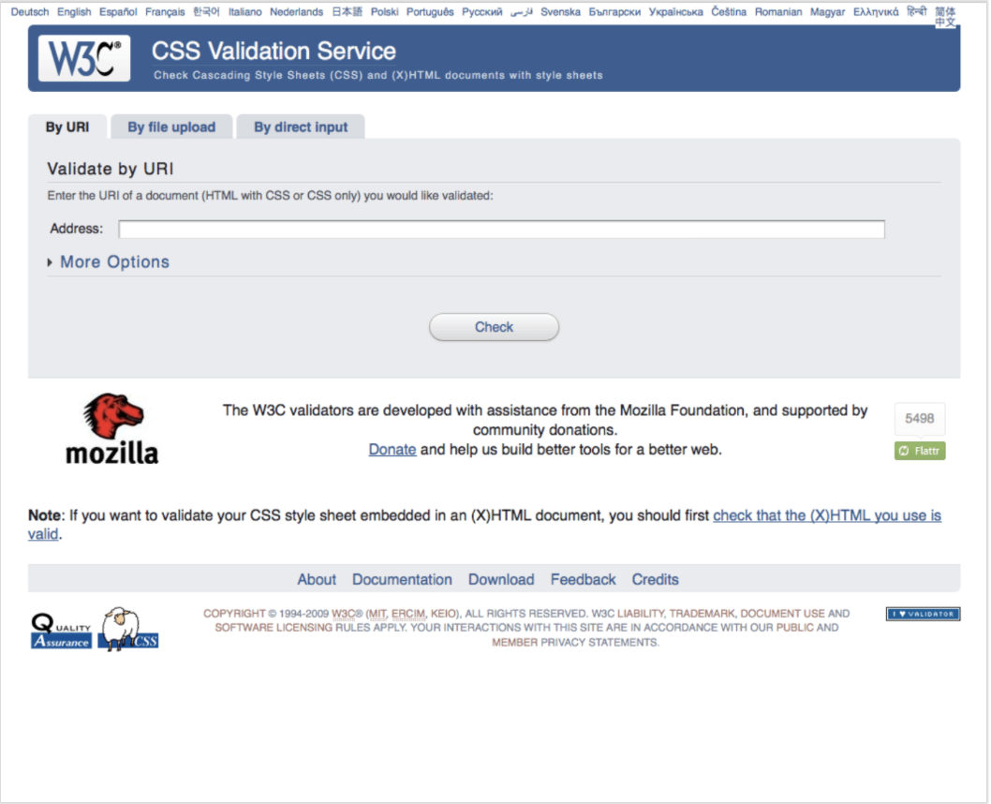

**Recommendation**

* How to Debug CSS (<http://web.jobbole.com/87818/>)
* Debug CSS (<https://developer.mozilla.org/en-US/docs/Learn/CSS/Introduction_to_CSS/Debugging_CSS>)
* Get started with HTML, CSS and Javascript Debugging (<https://www.cnblogs.com/PurpleTide/archive/2011/11/25/2262269.html>)